Feb 3, 2016

+[anil vishwakarma](https://plus.google.com/109876237885104232471) The Project Loon's FAQ says: "We’re looking for partners who can help us iterate on the technology. Please fill out this form, and we’ll be in touch if there is an opportunity to work together", with the link: <https://services.google.com/fb/forms/loonpartnerships/>

(Rick and David – what ya think? Does the below images have merit enough that Loon guys might be intrigued?)

Thus, the Plan:

1. Contact them “cold” via above link. Send them to “solarsett.com/weloveloon”, where there will be some CAD images of the following.
2. But, before that: I need validation from David and Rick that – this design has merit.
3. The gambit is that, our provisional will protect us, and that – if SolarSETT is as meaningful to them to want it, they will want to make arrangements with us vs, risking to go ahead and see if we get the patent.
4. The benefits are that, now they get 100 watts. But, if we can generate 3x to 7x more, then they can make the balloons more robust and want to keep it up longer (they seem to be targeting 200 days, from the 100 days) to even say 1+ year. Also, the additional power may mean that they can expand their coverage and bandwidth. I assume that the cost of having these things to have such short lifespan is very high (they have “chase and pick them up all over the world”. If they can figure out how to make the balloons more durable, AND extra power – it must be a huge benefit to them.
5. **IDEA to propose and put at the above link:**
   1. I want to put the SolarSETT balloon **inside** their balloon. There are 3 basic configs
      1. Top part of their balloon – Fig 1. And Bottom part of their balloon – Fig 2.
         1. These will our our standard variation and have the reflective part in the center and the PV cells either at the top part of our balloon or their balloon’s center (inside) part if that is a better focal point.
         2. The shape of the reflective part can be flatter or more parabolic – depending on what is the ideal.
      2. “Angled” towards the sun – inside their balloon – Figs 3 to 6.

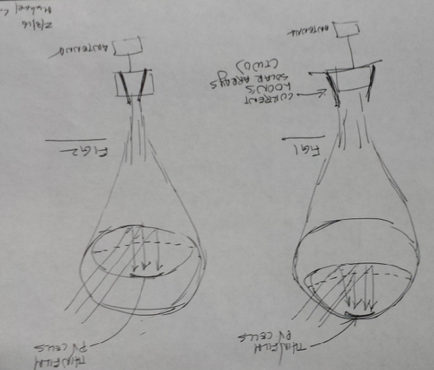

* 1. Angled: I want to suspend/hang SolarSETT concentrator between the top and bottom part of their balloon AND to have its reflective part more vertical and angled toward the sun. Now, then then question is how to have it face the sun and not just torque uncontrolled.
     1. Attach a gear in the main balloon’s attachment to the hanging arm to turn the transparent face of the SolarSETT concentrator toward the sun. We can determine the direction of the sun from any of many ways.

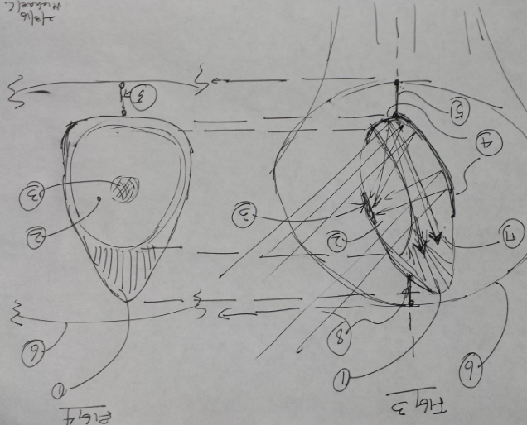 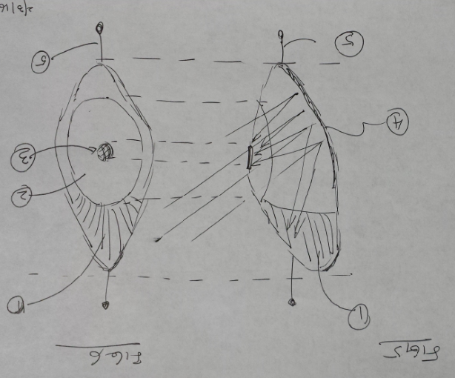

Above: Ignore the weird shape* of the above angled balloon images – they can be nice round shapes: 1) is the angled balloon 2) is the transparent face 3) is the PV cell 4) is the reflective part 5) ad 8) are the cord/stiff arm that attaches the concentrator to the top center and bottom center of the Loon balloon 6) is the Loon balloon 7) in Fig 3 is representation of the reflected photons going to the “top part of the concentrator”*. (* I had thought that, if I make a large pocket (which is off center) for heated air to be trapped in the top part of the concentrator, plus having a black top (to absorb sun more), shown in the 1) in Figs 5 and 6, then the long off center shape of the concentrators (and thus the weird shapes above) would orient by itself (without having been adjusted by gear) to be toward the sun. But Jon told me (after I drew the aboves) that, that will not work because the gas will equalize quickly and that to use gear.

* It’s too hard to orient the entire balloon to the sun, but for a reflector hanging on its inside is a different matter.

Fact: I think that the Loon balloons have a “parachute” on its exterior, and that is the looseness of the balloon in its images. The parachute is there for extra safety when they bring the balloons down after 100 days.

<http://www.google.com/loon/how/>

<https://plus.google.com/+ProjectLoon>

<https://plus.google.com/+ProjectLoon?pli=1>

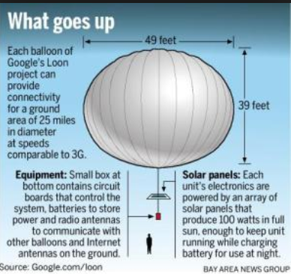

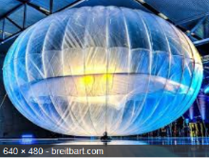 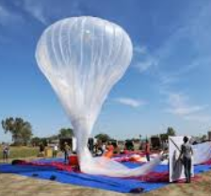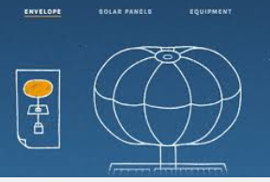

They seem to have something inside the main balloon, below:

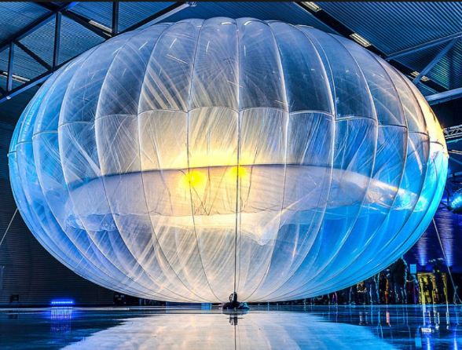

BTW, FYI: <http://www.powerfilmsolar.com/> possible “partner”? They seem to be the mfg. for the balloon or solar cells – I don’t know yet. Iowa.

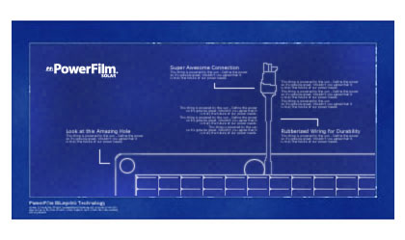

**We offer the only end-to-end custom solar module solution, working with partners from project conception to development to production, resulting in 100 percent custom solar modules.**

<<MC: They seem to be involved in sats and Goolge Loon. 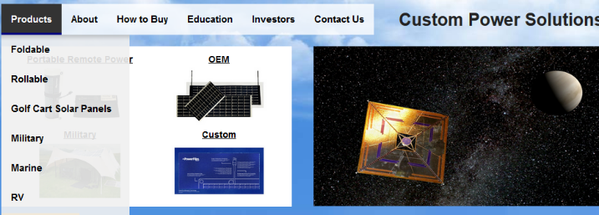

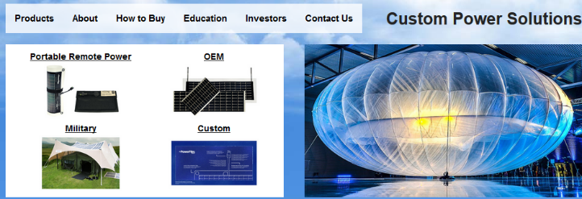

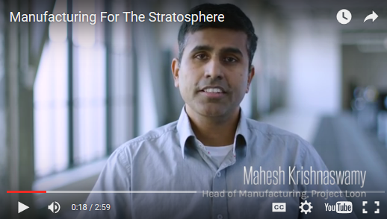

[Badri “Hippo” Sunderarajan's profile photo](https://plus.google.com/101670541558221615067)

[Badri “Hippo” Sunderarajan](https://plus.google.com/101670541558221615067)+1

+[anil vishwakarma](https://plus.google.com/109876237885104232471) The Project Loon's FAQ says: "We’re looking for partners who can help us iterate on the technology. Please fill out this form, and we’ll be in touch if there is an opportunity to work together", with the link: <https://services.google.com/fb/forms/loonpartnerships/>

PowerFilm® is a global industry leader in custom OEM solar module solutions. With highly diverse product offerings, PowerFilm has the proven agility and engineering expertise to meet partner objectives of nearly any capacity.

**Why partner with PowerFilm?**

* Create an optimized solar solution matching your exact needs.
* Develop innovative and appropriate solar integration techniques.
* Diagnose ideal size and shape of solar modules based on application.
* Determine the best suited solar power and voltage requirements.
* Provide consultation and engineering assistance.
* Experience with a wide variety of solar module integration options, including fabric, adhesive backings, magnetic backings and many more.

With the capability to adjust production characteristics and the agility to alter direction quickly, PowerFilm, Inc. is the only company in the solar industry that can offer a fully custom solar module solution with reasonable minimums and costs.

## Business Description

PowerFilm, Inc. is a developer and manufacturer of thin, flexible solar panels based on a proprietary production process. PowerFilm is based in Ames, Iowa, in the United States.

PowerFilm was founded in 1988 by Dr Frank Jeffrey and Dr. Derrick Grimmer, both former 3M research physicists, with a combined 67 years of experience in semiconductor and solar energy research and development. Since 1988, the Company has focused on developing thin film solar panel technology and products and custom engineering capabilities to meet specific application needs of the customers. Elements of the Company's technology and manufacturing process includes the use of: a durable, flexible plastic substrate; roll-to-roll manufacturing to minimize handling costs; amorphous silicon; and printed interconnects to automate the cell connection process.

## Board of Directors

* **Dr. Frank Jeffrey, Co-Founder and Chief Executive Officer**
  + Has worked in the semiconductor and solar energy field since 1972
  + Before founding PowerFilm, was a Senior Physicist at 3M (1982 - 1988) and prior to that a Research Physicist and Program Manager at the US Department of Energy's National Renewable Energy Laboratory and a Process Engineer at Texas Instruments Inc
  + PhD in Physics from Iowa State University
* **Dr. Derrick Grimmer, Co-Founder and Non-Executive Director**
  + Has worked in the semiconductor and solar energy field since 1975 and has retired from PowerFilm as a Principal Scientist
  + Before founding PowerFilm, was a Research Specialist at 3M, a Research Engineer at New Mexico Solar Energy Institute and Staff Member at Los Alamos National Laboratory, Solar Energy Group
  + PhD in Physics from Washington University in St. Louis
* **David Lindop, Non-Executive Director**
  + Currently Finance Director of Waterbridge Group, a UK-based property investment company with assets in excess of £100m
  + Has served senior financial roles including Finance Director in a number of companies including Speciality Shops plc (1987 - 1997) and Regalian Properties plc (1998 - 2001), both LSE listed companies
  + Has acted as a Non-Executive Director of AIM listed medical devices company Tissue Science Laboratories plc since 2001
  + BA (Hons) in Economics and Politics from the University of Sheffield
* **Rick Brimeyer, Non-Executive Chairman**
  + Rick Brimeyer has extensive experience in process improvement of manufacturing operations.
  + Mr. Brimeyer is the President of Brimeyer LLC, an independent management consulting firm located in Ames, Iowa, which guides organizations to higher performance by focusing on process improvement.
  + Prior to founding his own company, Mr. Brimeyer enjoyed a 25-year career at Sauer-Danfoss, a worldwide leader in the design, manufacture and sale of engineered hydraulic and electronic systems and components, used primarily in mobile equipment.
  + His career includes more than 22 years in leadership positions in engineering, operations and continuous improvement.
  + While at Sauer-Danfoss, he served as the Six Sigma Master Black Belt for the company's North American plants and was the lead Lean practitioner for the North American Propel division.
  + Mr. Brimeyer is the author of 5S Leader's Field Guide: Practical Advice for Establishing a Healthy 5S Culture Within Your Organization.

# [Why is the QBO important?](http://contextearth.com/2015/11/19/why-is-the-qbo-important/)

Posted on [November 19, 2015](http://contextearth.com/2015/11/19/why-is-the-qbo-important/)

After making a [breakthrough on modeling the Quasi-Biennial Oscillation of atmospheric winds (QBO)](http://contextearth.com/2015/10/22/pukites-model-of-the-quasi-biennial-oscillation/qbo_paper) and simultaneously [debunking](http://contextearth.com/2015/11/14/whuts-up-with-posting-all-these-qbo-fits/) the fearsome [AGW skeptic](http://forum.azimuthproject.org/discussion/comment/15006/#Comment_15006) Richard [Lindzen](https://forum.azimuthproject.org/discussion/comment/15005/#Comment_15005)'s original theory for QBO, it might be wise to take a step back and note the potential significance of having a highly predictive model.

Mr. Eustace said he gained a love of space and spaceflight while growing up in Orlando, Fla., during the 1960s and 1970s. His family crowded into a station wagon to watch every launch from Cape Canaveral (known as Cape Kennedy during some of that time). A veteran aircraft pilot and parachutist, he worked as a computer hardware designer at Digital Equipment Corporation for 15 years before moving to Google in 2002.

Mr. Eustace said that his technical team designed and redesigned many of the components of his parachute and life-support system during the three-year development phase. Many of the redesigns were the result of technical surprises.

For example, he discovered that in order to control his suit, he was required to make movements that were exactly the opposite of the control motions made by a conventional parachutist. Left movements must be made for rightward motion, for instance, and upward movements for downward motion.

The stratosphere becomes warmer at higher elevations, and the suit designers had to figure out how to keep Mr. Eustace sufficiently cool at the top of the stratosphere, because there is no atmosphere to remove the heat.  His suit did not have a cooling system, so it was necessary to make elaborate design modifications to keep dry air in his helmet so that his face plate did not fog.

In order to keep from overheating, Mr. Eustace kept his motions to a minimum during his ascent, including avoiding moving his arm to toggle a radio microphone. Instead, he responded to ground controllers watching him from a camera rigged above his suit by slightly moving one leg to acknowledge their communications.

**Correction: October 24, 2014**   
An earlier version of this article misstated the relationship of temperature to elevation in the stratosphere. In the upper layers of the stratosphere, temperatures increase with altitude, not decrease.